WEEK – 3

Exercise 1: Configuring a Basic Spring Application

Nipuna.A

Superset id: 6432842

**Scenario:**

Your company is developing a web application for managing a library. You need to use the Spring Framework to handle the backend operations.

**Steps:**

1. **Set Up a Spring Project:**
   * Create a Maven project named **LibraryManagement**.
   * Add Spring Core dependencies in the **pom.xml** file.
2. **Configure the Application Context:**
   * Create an XML configuration file named **applicationContext.xml** in the **src/main/resources** directory.
   * Define beans for **BookService** and **BookRepository** in the XML file.
3. **Define Service and Repository Classes:**
   * Create a package **com.library.service** and add a class **BookService**.
   * Create a package **com.library.repository** and add a class **BookRepository**.
4. **Run the Application:**
   * Create a main class to load the Spring context and test the configuration.

Solution:

1)pom.xml

<project xmlns="http://maven.apache.org/POM/4.0.0"

         xmlns:xsi="http://www.w3.org/2001/XMLSchema-instance"

         xsi:schemaLocation="

           http://maven.apache.org/POM/4.0.0

           http://maven.apache.org/xsd/maven-4.0.0.xsd">

    <modelVersion>4.0.0</modelVersion>

    <groupId>com.library</groupId>

    <artifactId>LibraryManagement</artifactId>

    <version>1.0</version>

    <dependencies>

        <!-- Spring Core Dependency -->

        <dependency>

            <groupId>org.springframework</groupId>

            <artifactId>spring-context</artifactId>

            <version>5.3.34</version>

        </dependency>

    </dependencies>

    <build>

        <sourceDirectory>src/main/java</sourceDirectory>

        <resources>

            <resource>

                <directory>src/main/resources</directory>

            </resource>

        </resources>

        <plugins>

            <!-- Plugin to run main method -->

            <plugin>

                <groupId>org.codehaus.mojo</groupId>

                <artifactId>exec-maven-plugin</artifactId>

                <version>3.5.1</version>

                <executions>

                    <execution>

                        <goals>

                            <goal>java</goal>

                        </goals>

                    </execution>

                </executions>

                <configuration>

                    <mainClass>com.library.App</mainClass>

                </configuration>

            </plugin>

        </plugins>

    </build>

</project>

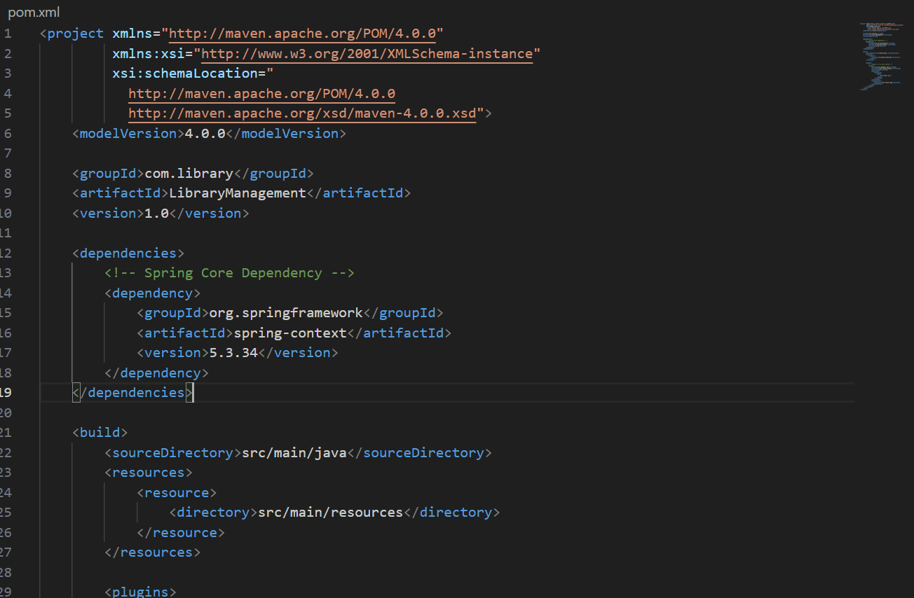

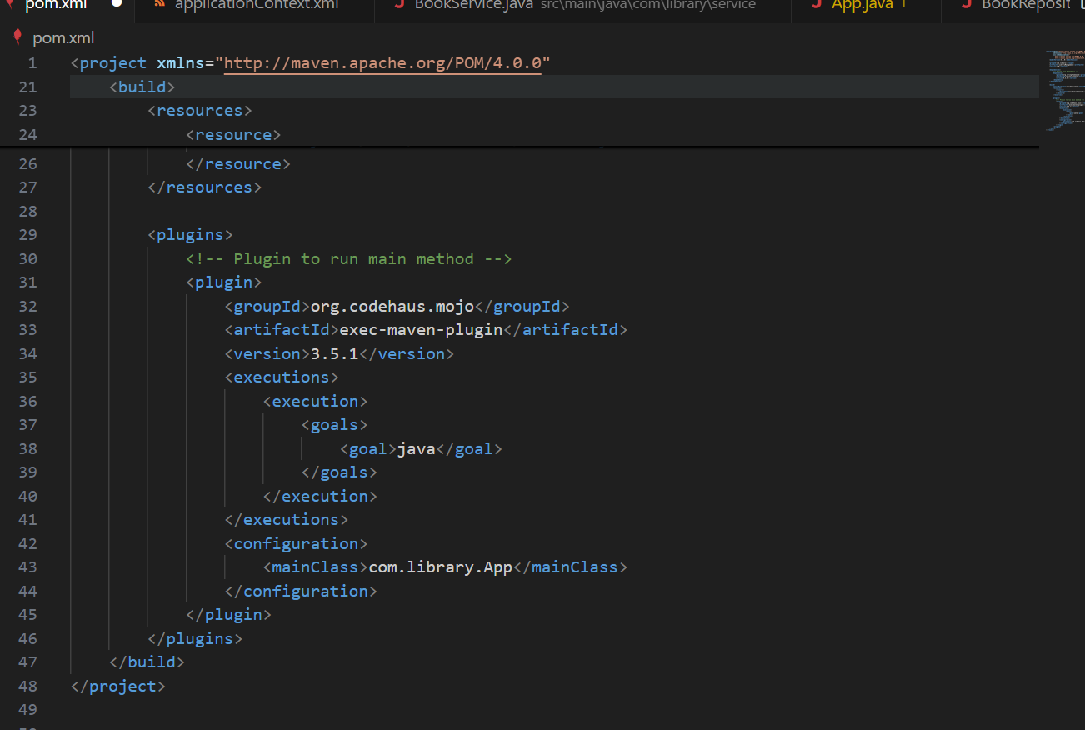

2) applicationContext.xml

Location: LibraryManagement/src/main/resources/applicationContext.xml

<?xml version="1.0" encoding="UTF-8"?>

<beans xmlns="http://www.springframework.org/schema/beans"

       xmlns:xsi="http://www.w3.org/2001/XMLSchema-instance"

       xsi:schemaLocation="

           http://www.springframework.org/schema/beans

           http://www.springframework.org/schema/beans/spring-beans.xsd">

    <bean id="bookRepository" class="com.library.repository.BookRepository" />

    <bean id="bookService" class="com.library.service.BookService">

        <property name="bookRepository" ref="bookRepository" />

    </bean>

</beans>

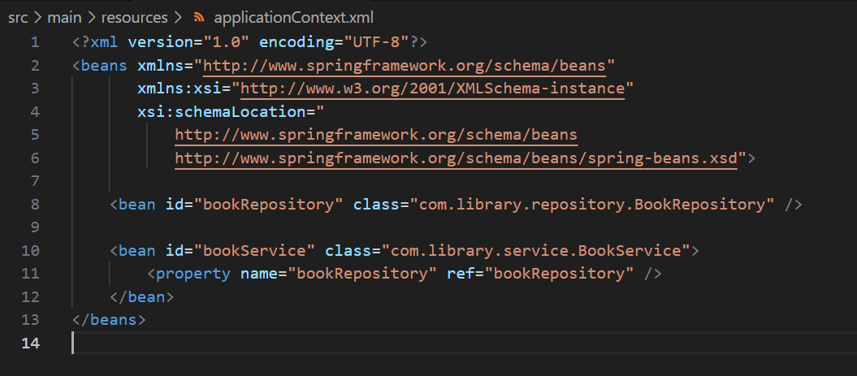

3) BookRepository.java

Location: LibraryManagement/src/main/java/com/library/repository/BookRepository.java

package com.library.repository;

public class BookRepository {

    public void saveBook(String bookName) {

        System.out.println("Book saved: " + bookName);

    }

}

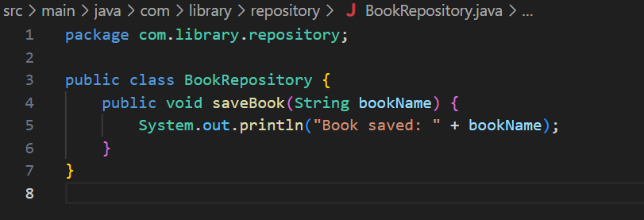

4) BookService.java

Location: LibraryManagement/src/main/java/com/library/service/BookService.java

package com.library.service;

import com.library.repository.BookRepository;

public class BookService {

    private BookRepository bookRepository;

    public void setBookRepository(BookRepository bookRepository) {

        this.bookRepository = bookRepository;

    }

    public void addBook(String bookName) {

        bookRepository.saveBook(bookName);

    }

}

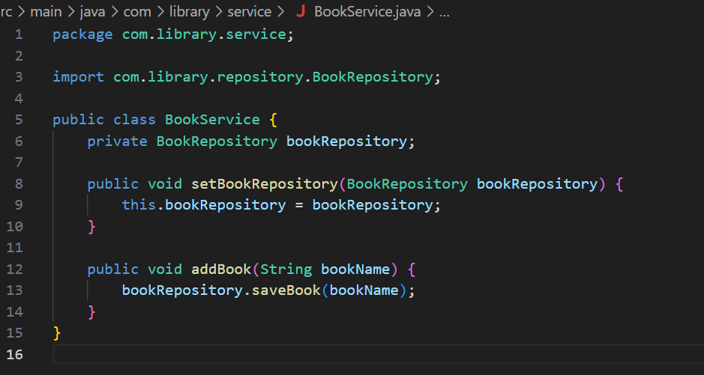

5) App.java

LibraryManagement/src/main/java/com/library/App.java

package com.library;

import com.library.service.BookService;

import org.springframework.context.ApplicationContext;

import org.springframework.context.support.ClassPathXmlApplicationContext;

public class App {

    public static void main(String[] args) {

        ApplicationContext context =

            new ClassPathXmlApplicationContext("applicationContext.xml");

        BookService bookService = (BookService) context.getBean("bookService");

        bookService.addBook("Spring Framework Basics");

    }

}

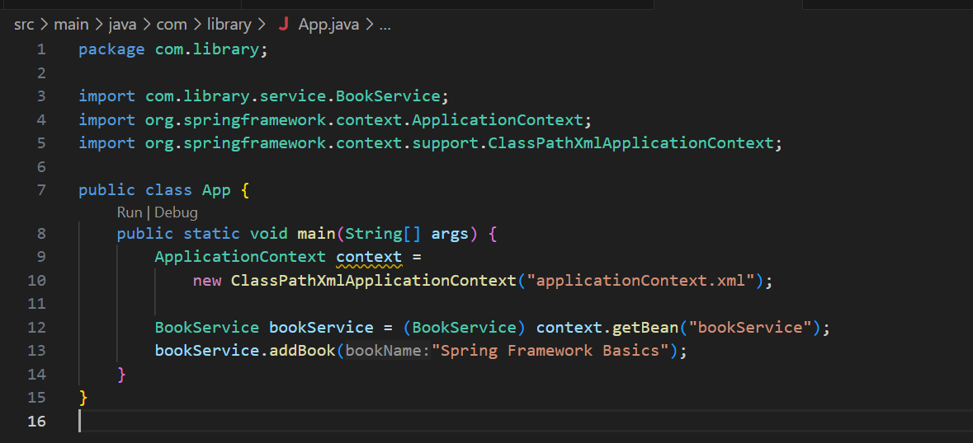

Output:

